**Project Phase 1**

Deliverable 3

**1. Requirements for Phase 1**

We have accomplished implementing the fundamental functionalities of the established e-commerce platform for our project that were in the Phase 1 plan. The following is the summary of some of the requirements that has been met:

1. User Authentication and Profile:
   * User registration using full name, email and password
   * Profile information of the user (addresses, payment methods, orders made)
2. Product Listing and Filtering:
   * Considering the layout aspect the current design of the product listing page is a grid layout with pagination.
   * Added features for sophisticated filter (category, price, brand, rating, availability)
   * Simple product cards with images, text descriptions and action buttons
3. User Interface for Login, Signup, and Products:
   * Adaption to provide an efficient experience in different devices sizes
   * Minimalist and clean website design with specific product listing and general categories
   * Ease of access with comprehensive header feature and easy menu.
4. Search and Filter Functionality:
   * Ability to search product based on name, brand and other attributes
   * Filtering implemented on the current results page
5. Recommendation Engine (Initial Development):
   * Structural model for database of the behaviors of users
   * Development of the “Recommended for You” tab to provide recommendations based on user’s preferences

This implementation would work as a foundation to the e-commerce site in which interaction with user interface inclusive of features for products navigation, search and purchase is offered. The layout of the general structure of the system can be considered as scalable, and is designed to be further developed in the subsequent stages of the project.

**2. UML Design for Phase 1**

**Class Diagram for Phase 1**

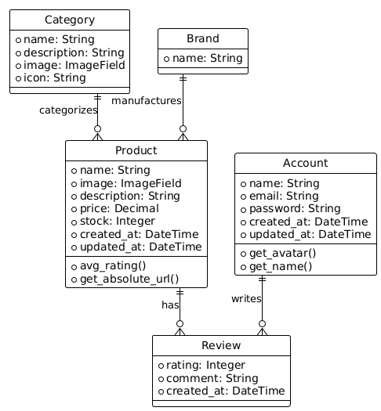

This figure is one of the special class diagrams which illustrates the relations of the main classes in our e-commerce system. It presents distinguish features of each class and the methods used and thus giving a clear picture on the system.

**Sequence Diagram for Phase 1**

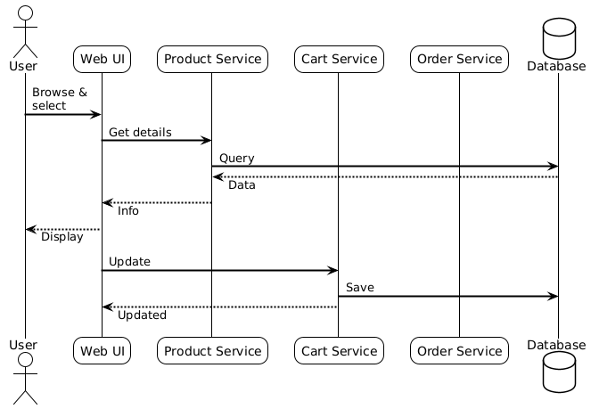

This sequence diagram shows a general user participation platform in our e-commerce system from the login process till the purchase process. It also focuses on the interactions of the different components with a system and how information passes from one component to the other.

**Use Case Diagram for Phase 1**

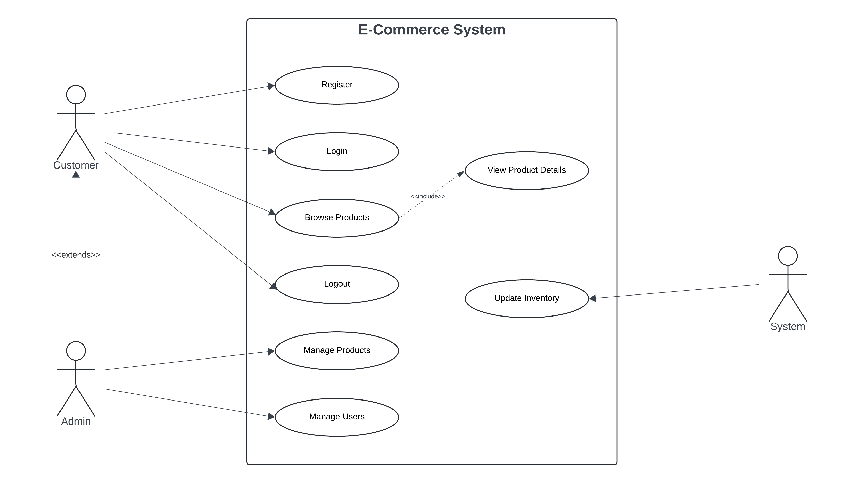

Figure 1- Normal Case

The following use case diagram illustrates an error case, specifically authentication error during user login such as invalid credentials being supplied:

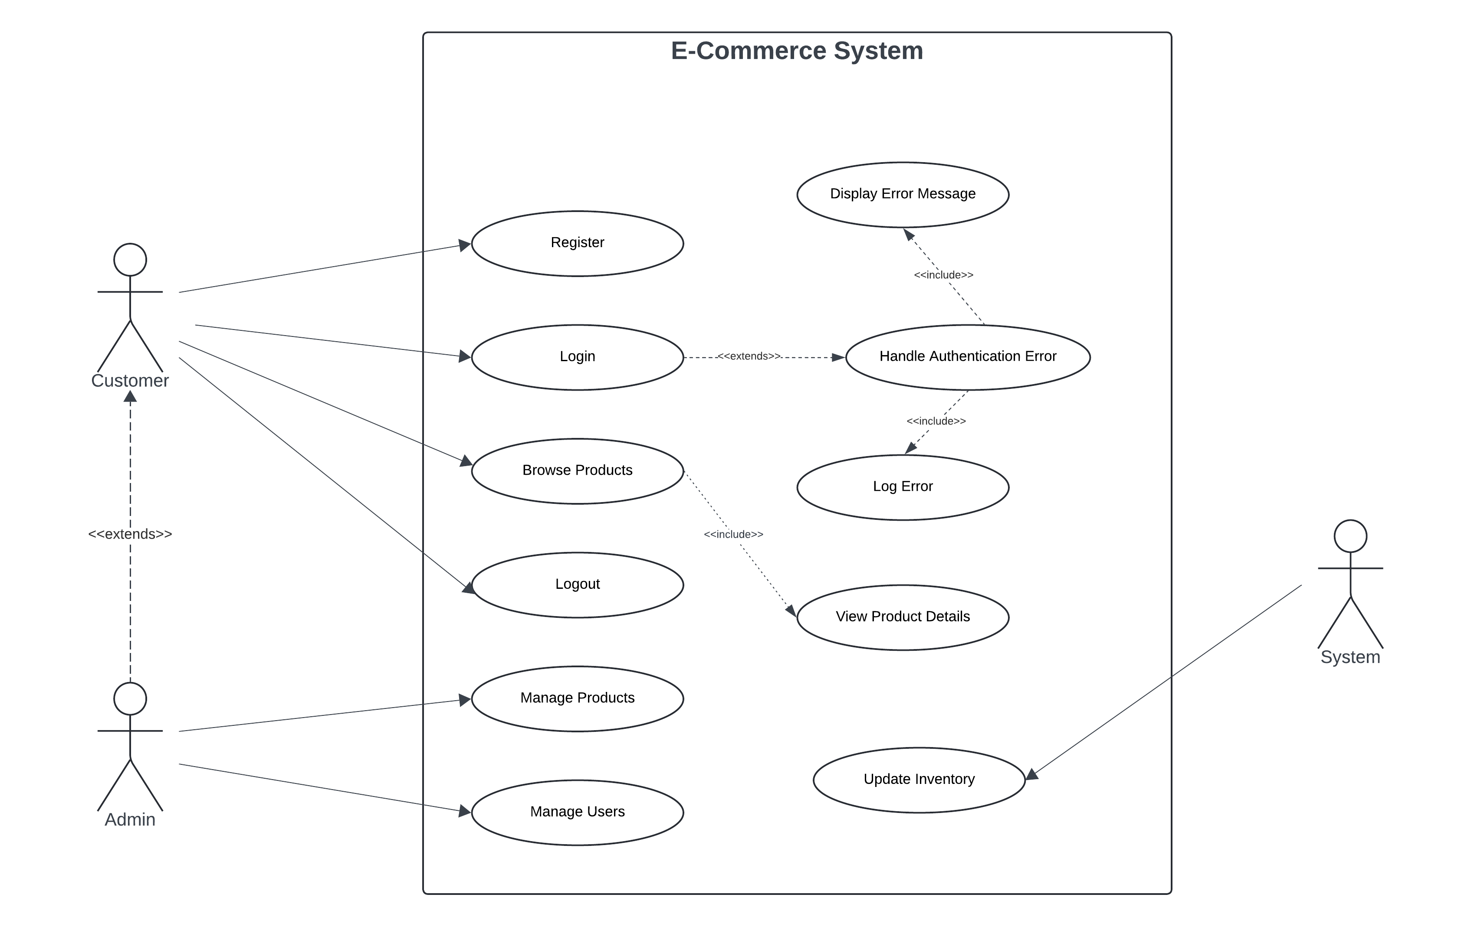

Figure 2 - Error Case

As depicted from this use case diagram, the system encompasses a number of functionalities from the customer’s and admin’s point of view. It also shows all user actions that occur in the context of the system and their relation to the multiple services.

**3. Test Cases**

**3.1 Project Setup Test**

Checks the status of the project from initial creating of the clone from the repository to the booting of the server. Ensures the application runs without errors and is accessible at [http://localhost:8000](http://localhost:8000/).

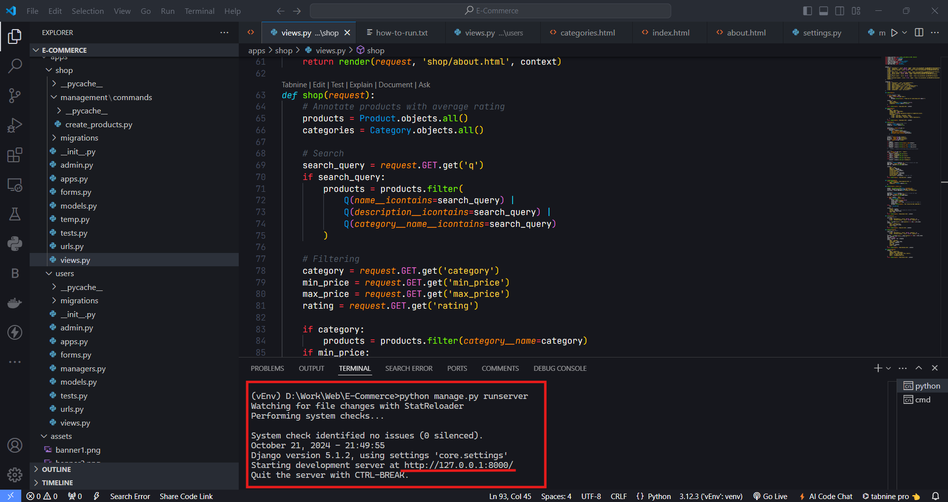

**3.2 User Interface Design Test**

Verifies that the definition of the look and feel of the application is implemented in all the pages of the UI. Affirms the overall style is maintained and the site’s layout easy to negotiate throughout all the pages.

**3.3 Large Screen Responsiveness Test**

Checks how site performs on large screens desktop: 1920×1080 and tablet: 1366×1024. Makes sure that the content fits the page and there is no horizontal scrolling and all buttons are clickable.

**3.4 User Registration Test**

Verifies the signup of new users that has been implemented.

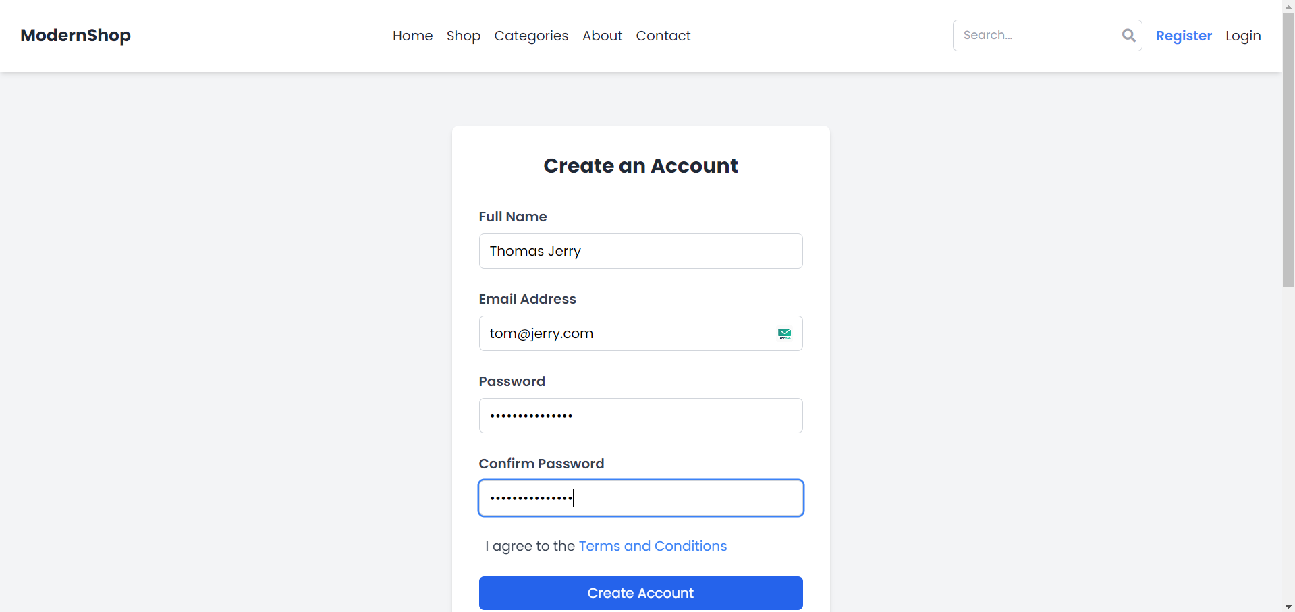

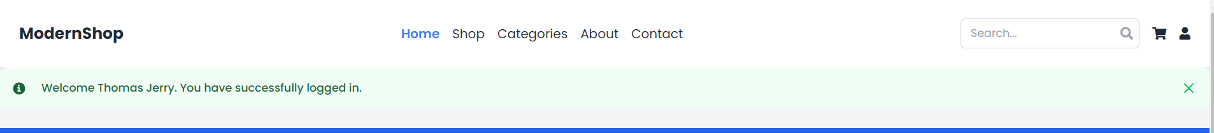

Verifies if the account creation is successful and if the user is redirected to the correct page or not and if a user can be able to log in with new credentials.

**3.5 User Login Test**

Allows to register new users and guarantees their log in.

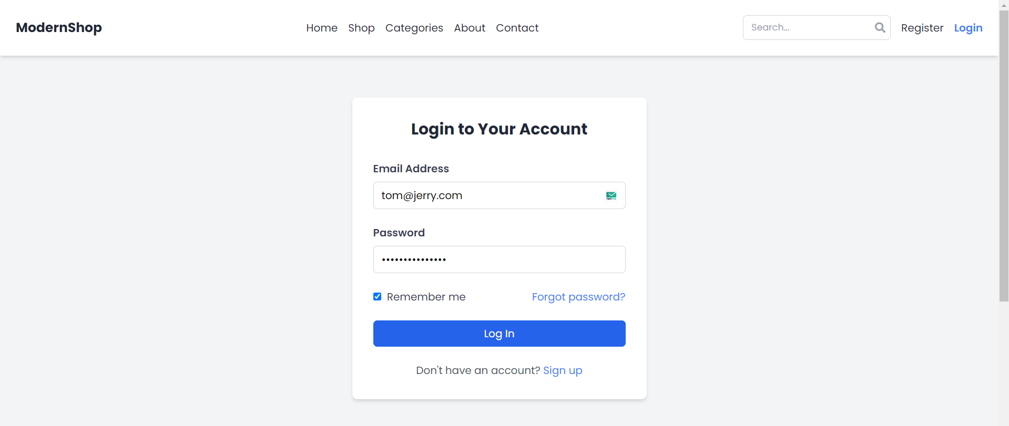

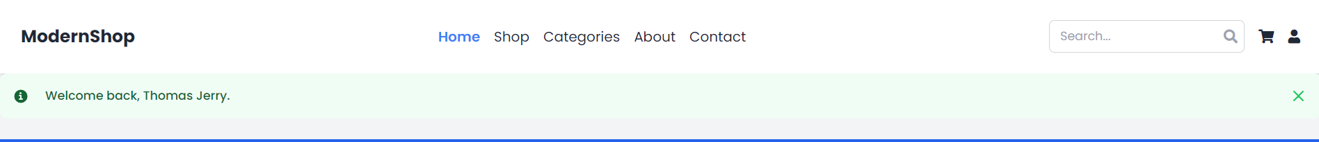

In other words, it will ensure that the system has correctly authenticated the user, the proper web pages had been redirected and user-specific contents were displayed correctly.

**3.6 Product Addition Test (Admin)**

Verifies an ability of an admin to add new products by using the admin interface.

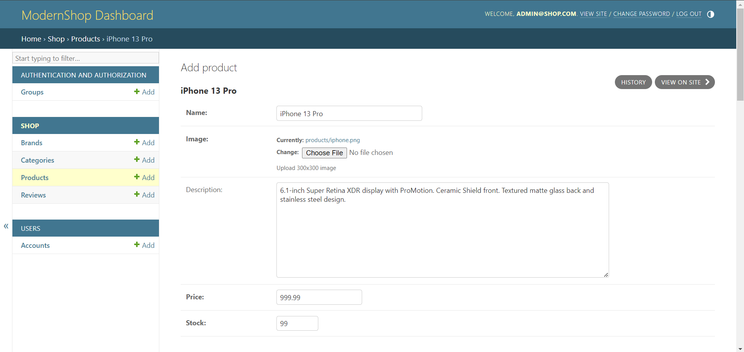 It checks whether the product is included into both admin panel and main site product lists.

**3.7 Product Listing Test**

Verifies proper display of products on the main index page.

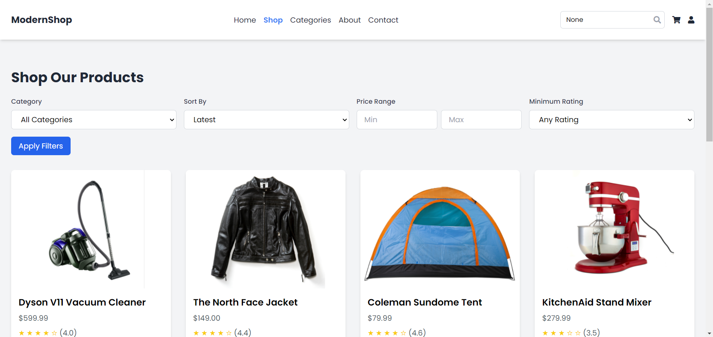

Checks the correct display of the product images, nomenclature, price among others.

**3.8 Product Filtering Test**

Affirms the usability of the filtering mechanisms for the products.

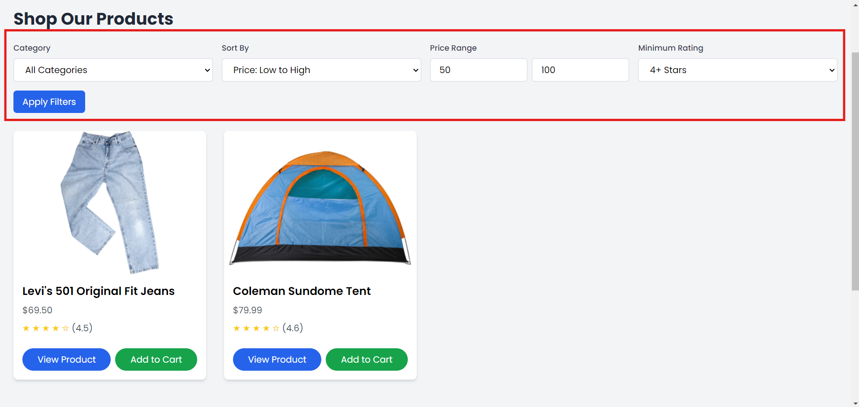

Enables the correct calculation of the results of individual and combined filters, as well as the convenience of their use.

**3.9 Product Pagination Test**

Focuses on the page management of products that is usually implemented during a product creation process.

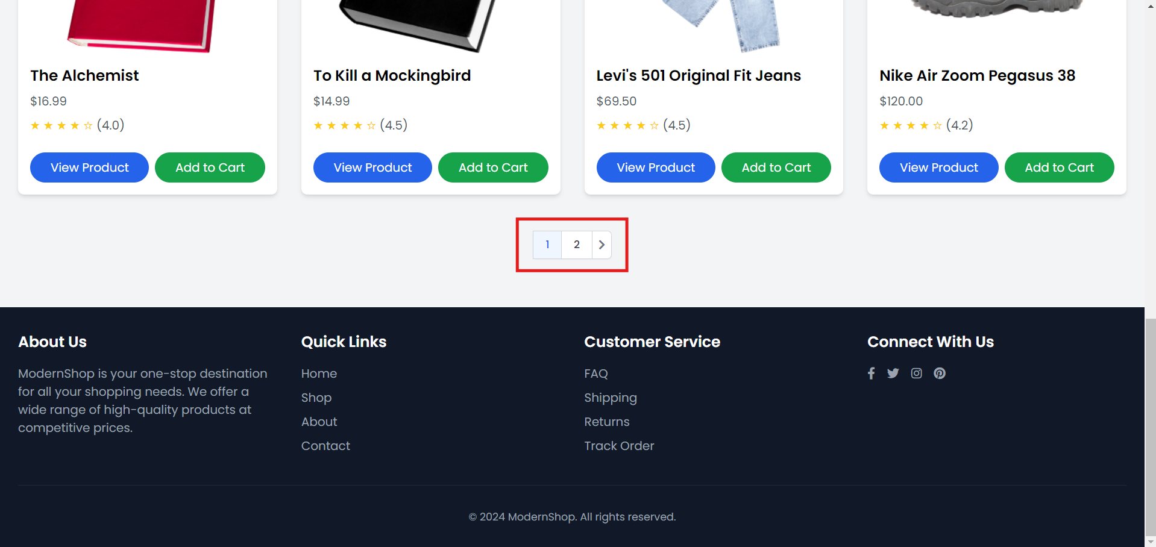

Ensures the right product is displayed per page as well as correct page transition.

**3.10 User Password Change Test**

It tests the functionality of changing user password.

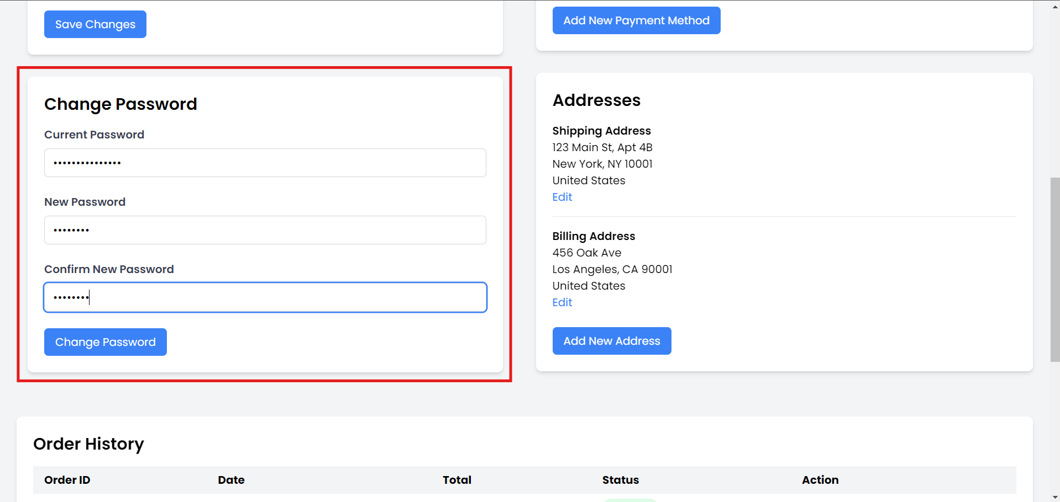

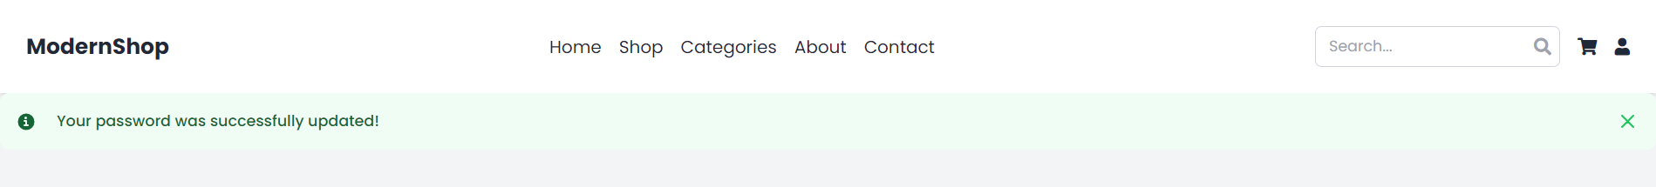

Ensures that password update is successful and capable of being entered to log in the account on the website.

**3.11 User Profile Update Test**

Checks if the users can edit them personal details.

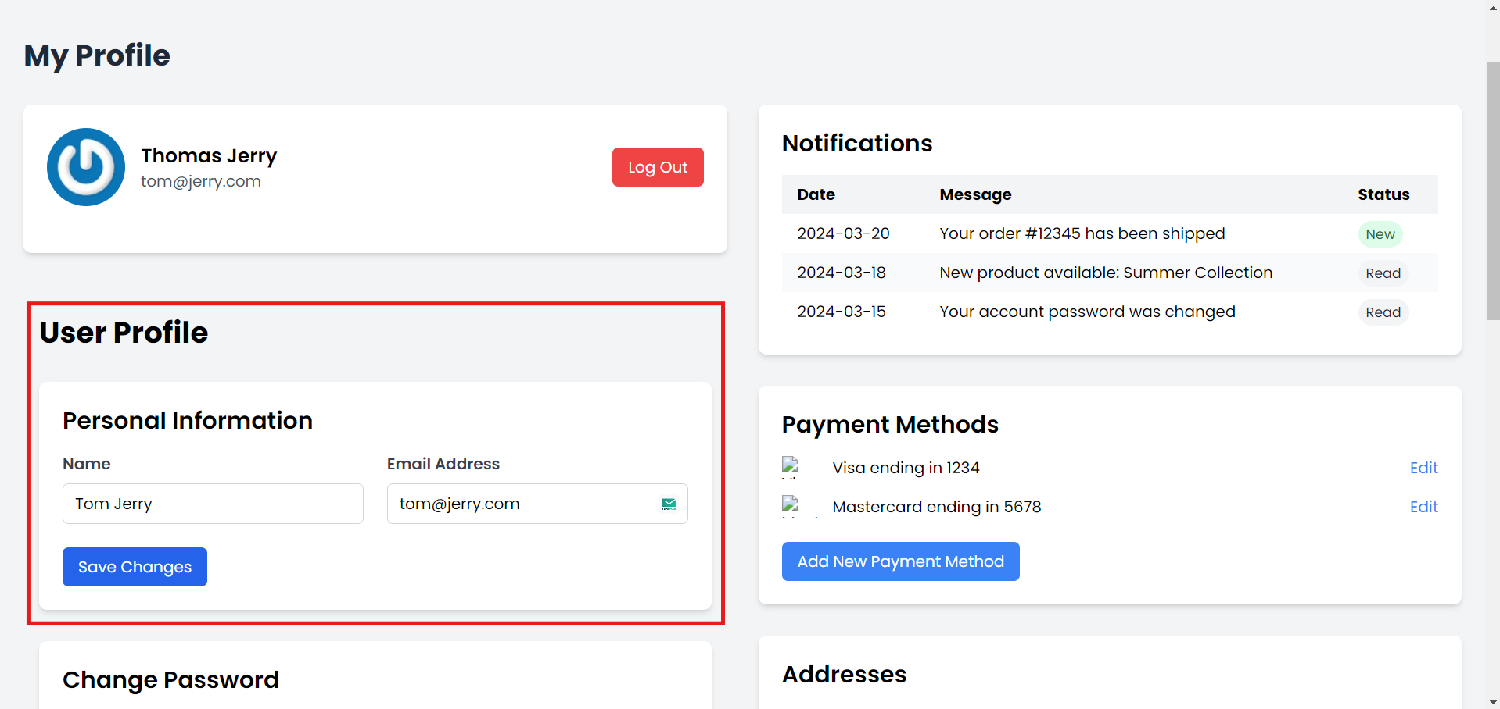

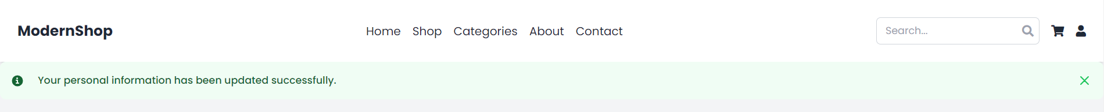

Itinerary of changes is saved and made effective at once and are retained even after the user logs out and logs back in.

**4. User Manual**

In this user manual you will find information on how to install the application and some tips on navigating through our application.

**Installation Instructions:**

1. System Requirements:
   * Python 3.8 or higher
   * pip (Python package manager)
   * Git
   * PostgreSQL 12 or higher
2. Clone the Repository: Open a terminal and run the following command: make new project directory and download it from the GitHub repository: $ git clone https://github.com/your-repo/ecommerce-project.git
3. Navigate to the Project Directory: cd ecommerce-project
4. Create a Virtual Environment: python -m venv venv
5. Turn On the Virtual Environment:
   * On Windows: venv\Scripts\activate
   * On macOS and Linux: source venv/bin/activate
6. Install Dependencies: pip install -r requirements.txt
7. Define run Migrations python command is manage.py migrate.
8. Create a Superuser: python manage.py createsuperuser

Follow the prompts to create an admin account.

1. Run the Development Server: python manage.py runserver
2. Access the Application: Now click your web browser and type the URL http://localhost:8000

**Using the Application:**

1. Homepage Navigation:
   * The homepage also categorizes products by different sections and highlights special products.
   * The main navigation bar is located at the top of the page to help you find different types of products, your cart and account.
2. Searching for Products:
   * You can also search for specific products using the search bar placed at the top of the page.
   * There will be suggested options appearing when you type in the word.
   * Press enter or click on a suggestion to expand the search results.
3. Browsing Products:
   * By clicking on a category, one sees all the products that fall under that given category of products.
   * You can use the search criteria located on the left side bar of the product listing page to sort the products by price, brand, rating, and the like.
   * More details of a product can be viewed by clicking on the image of the product.
4. Adding Products to Cart:
   * On, the product detail page, choose the quantity and click ‘Add to Cart’.
   * You receive confirmation and the cart on the top right corner will display the number of items in the cart.
5. Managing Your Cart:
   * Select the cart icon to display your current cart at any time.
   * Just change proportions or delete products as desired.
   * When ordering, just click on ‘Proceed to Checkout’ button when you are finished.
6. Checkout Process:
   * Review your cart items.
   * Enter or select your shipping address.
   * Choose a shipping method.
   * Enter your payment information.
   * Review your order summary and click "Place Order" to complete your purchase.
7. Account Management:
   * Click on your username in the top right corner to access your account settings.
   * Here you can view your order history, manage addresses, and update your profile information.
8. Writing Product Reviews:
   * Navigate to a product you've purchased.
   * Scroll down to the "Customer Reviews" section.
   * Enter your experience with the product and submit the review.

**5. Compilation Instructions**

To run the program:

1. Make sure you are in the project directory and your environment has been activated in the terminal.
2. Run the development server: python manage.py runserver
3. Access the application by opening a web browser and navigating to http://localhost:8000

**6. Peer Review Feedback**

In the course of our peer review, our partners provided us with useful comments. Here's a summary of the key points and the actions we've taken in response:

1. Feedback: Bring about a better product listing

Action Taken: You will notice that we have adopted the CSS Grid and Flexbox to produce a fluid grid layout depending on the display size to increase the adaptability of the product listing on a variety of screens. We have also in the process of implementing image loading and reducing image sizes to allow faster loading – even using ‘lazy loading’ for images on mobile devices.

1. Feedback: Add more detailed product descriptions

Action Taken: We have added more fields to our product model concerning technical characteristics of products, their fabric content and washing instructions. To provide the customer with all this information conveniently, the product detail page now has a tabbed format.

1. Feedback: Improve the checkout process flow

Action Taken: When it comes to checkout, we’ve done away with multi-page checkouts to replace them with a single-page checkouts where each section is collapsible. It also enables users to consider details when reviewing them as an and edit them without the need to use other pages.

1. Feedback: Implement a more robust recommendation system

Action Taken: Our recommendation system is being developed to be more capable of not just looking at past purchases, but also at things the customer has looked at and items similar to what they have bought. We’re now aiming for powered by collaborative filtering and also leveraging content-based recommendation on the site.

All these improvements serve to significantly improve the user experience and usefulness of our e-commerce platform. It is great to receive feedback from other like-minded individuals and we will continue to use the input to enhance the created product based on user requirements and standards.

**7. Report Reflection**

As we conclude Phase 1 of our e-commerce project, it's important to reflect on our accomplishments, challenges, and areas for improvement.

Accomplishments:

1. Robust User Authentication: When it comes to user authentication, we were able to deploy an effective and secure user management system that has provisions for operations such as emailing a user their details and resetting a user’s password.
2. Comprehensive Product Management: The arrangement of our products and the source for filtering makes it easier for a user to go through and find products of their desire.
3. Responsive Design: To make the platform equally comfortable whether it is used on a computer, tablet, or smartphone, we’ve made a few key adjustments.
4. Advanced Search Functionality: It has also helped in improving our manner of searching for information by incorporating Elasticsearch.
5. Streamlined Checkout Process: By implementing this single-page checkout, we eliminated several steps of the ordering process with the expectation to boost the conversion rates.
6. Initial Recommendation System: We have set the stage for the recommendation system of products, which should improve the interaction with the user and might lead to increased sales.

What Went Well:

1. Team Collaboration: Due to the nature of the developed model as an agile software solution, a lot of feedback could be incorporated within the shortest time possible.
2. Code Quality: Hence, the authors followed best practices for code cleanliness when writing the code and fixed such issues as pattern abstractions that brought about a cluttered code style.
3. Testing: A combination of unit tests, regression tests, and other tests allowed us to negate various bugs at the stage of the game’s development.
4. User-Centric Design: Improving users’ requirements and including peers’ feedback resulted in enhanced and friendly graphical user interface.

Areas for Improvement:

1. Performance Optimization: This applies to regular browsing, and it is still possible to enhance the speed of the page load, particularly, where the density of picture content is high.
2. Database Query Optimization: Expanding the product catalog forces the system’s creators to fix potential scalability issues concerning queries to the database.
3. Enhanced Analytics: Expanding the product catalog forces the system’s creators to fix potential scalability issues concerning queries to the database.
4. Accessibility: The next step is performing an accessibility check on our site and making changes when needed in order for the site to be accessible.

As for the areas that can still be developed further, further actions towards improvement will be taken in the following year while the successes achieved will be maintained and expanded. As such, the major goal consists of developing an easily scalable and viable e-commerce system which will be comfortable for consumers as well as administrators.

**8. Member Contribution Table**

|  |  |  |  |
| --- | --- | --- | --- |
| **Member Name** | **Contribution Description** | **Overall Contribution (%)** | **Note (if applicable)** |
| Harini | UI/UX Design, contact, index, products, shop, meeting minutes, member contribution table, uml sequence diagram, manage | 12.5% |  |
| Osama | Report complication instructions, note deliverable file, core setup of the project | 12.5% |  |
| Nirupama | UI/UX Design, login, profile, register, reset-done, testcases, styling | 12.5% |  |
| Niharika | UI/UX Design, about, cart, categories, checkout, meeting minutes, use case diagram, testcases,manage | 12.5% |  |
| Jaswanth | Requirements, simplifies database management, user request, interact with models, note deliverable file, | 12.5% |  |
| Rajsekhar | Models, temp, tests, urls, views, management | 12.5% |  |
| Triveni | UI/UX Design, reset-email, reset-new, reset-success. | 12.5% |  |
| Sharanya | Class diagram, user manual, admin, apps, forms, migrations | 12.5% |  |

All the team members have worked together throughout the project and each of them has made his/her input according to his/her sphere of specialization towards development of the e-commerce platform. It has provided a sequential implementation that is best of breed and quite strong and balanced for the first pass at our system.